# Data Modelling Task

STAR schema: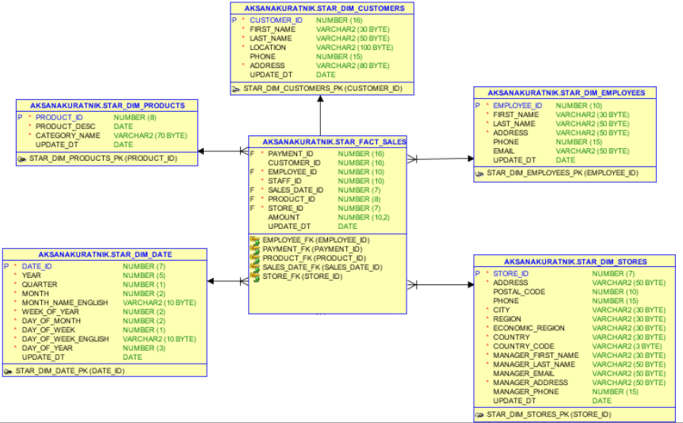

**4 Step Dimensional Process**

* **Step 1:** Select the Business Process

Business Process gives an opportunity to see company’s sales.

* **Step 2:** Declare the Grain

Each row in the table shows product that have been ordered by customer.

* **Step 3:** Identify the Dimensions

Table DIM_PRODUCTS contains product names, their categories.

Table DIM_STORES contains information about locations and contacts of the each store.

Table DIM_CUSTOMERS contains information about customers, their location and contact info.

Table DIM_EMPLOYEES contains all information about employees.

Table DIM_DATE contains all date information.

* **Step 4:** Identify the Facts

Payment_id, Customer_id, Employee_id, Staff_id, Sales_date_id, Product_id, Store_id, Amount, Update_dt .

SNOWFLAKE shema:

